2 Benchmarking Against Published Methods

2.1 Motivation and Reference Model
The ablation study in Chapter 1 compared variants of a single architecture. It cannot show whether that architecture is competitive with methods proposed elsewhere. This chapter therefore re-implements eleven published methods on the same three-class task (Normal, Leve, Moderada) and compares each with the best configuration from the ablation, called the reference model below.
The reference model uses only images (fingertip video, palm video and nail photograph), Bi-LSTM temporal pooling and self-attention fusion. Over five cross-validation folds it reaches a mean macro-F1 of 0.459 ± 0.075 and a macro-AUC of 0.715 ± 0.033. On the fixed test set of 123 subjects (87 Normal, 29 Leve, 7 Moderada) its fold-averaged F1 is 0.828 for Normal, 0.353 for Leve and 0.222 for Moderada, where it finds one of seven subjects. Accuracy (0.670) is not informative on its own: always predicting Normal gives 0.707. Macro-F1 is therefore the primary metric throughout, with macro-AUC as the threshold-free secondary metric.
The chapter answers one question in four steps: is the selected architecture competitive with methods published elsewhere? Section 2.2 explains which papers were used, what each one tests against the reference, who ran it and how; Section 2.3 compares the overall scores; Section 2.4 shows which classes each method gets wrong; Sections 2.5 and 2.6 state what the evidence does and does not support.

2.2 Benchmarked Methods and Protocol
Table 1 lists the eleven papers and the run reported for each. Table 2 states what each paper tests against the reference model, which team member ran it and what evidence the run leaves behind. Table 3 records each design decision with its reason. Together they show that every paper has a stated purpose, an owner and a saved record of the run.
Table 1. Benchmarked papers and the run reported for each.
ID | Source paper | Run reported | Comparability
B03 | Multi-input deep network for anaemia detection from nail images (ICBSII 2024) | EfficientNet-B4 with a* colour-statistics branch | Direct
B04 | Fusion strategies for multi-modal pneumonia classification (ICECTE 2026) | Intermediate fusion, MobileNetV3-S | Direct
B05 | Attentional Feature Fusion (Dai et al., WACV 2021) | AFF on ResNet-18 | Direct
B06 | Multimodal fusion of CT and electronic health records (Huang et al., 2020) | Late ElasticNet average (image + tabular) | Direct
B07 | Iron-deficiency anaemia detection with machine learning on nail, palm and conjunctiva images (Asare et al., 2023) | k-NN (k = 5) on 21 CIELAB colour features | Partial
B08 | Iron-deficiency anaemia with CNN ensembles (Murugeswari et al., 2025) | Majority vote of three ResNet-18 branches | Partial
B09 | BPANet, haemoglobin estimation from body-part images (Lin et al., 2025) | BPANet-adapted: ResNet-50, age and sex, haemoglobin head | Partial, single run
B10 | Multi-view classification with hybrid fusion and mutual distillation (MV-HFMD) | Hybrid CNN-Transformer, one frame per modality | Not direct, single run
B11 | Nail-image DenseNet169 for iron-deficiency anaemia (Navarro-Cabrera et al., 2025) | DenseNet169 on the nail image only | Not direct, single run
B12 | Multimodal fusion of EHR and conjunctiva images (Ramzan et al., 2024) | The paper’s RCBAM-MobileNetV2 image branch, nail photograph only | Not direct, single run
B13 | Machine/deep learning haemoglobin prediction from conjunctival images (Kato et al., 2024) | EfficientNet-B0 with GeM pooling, nail photograph | Partial, 5-fold CV
The eleven papers fall into four families, according to which part of the reference model they challenge: fusion strategy (B04, B05, B06, B10, B12), nail and colour features (B03, B07, B11), multi-body-part haemoglobin estimation (B09, B13) and ensembling (B08). Each family stands for a design choice that the reference model made, so a paper that is weaker than the reference still carries information about that choice.
Table 2. What each benchmarked paper tests against the reference model, who ran it, and the evidence kept for the run. Members are numbered as in the text.
ID | Member | What the paper tests against the reference | Evidence kept for the run
B03 | First | Whether a hand-crafted colour branch (a*) adds to a CNN on nail images, the same body site and task as the reference | Notebook, five-fold results, fold-averaged confusion matrix and ROC, loss curves, source paper
B04 | First | Early, intermediate and late fusion of several inputs, against the reference’s attention-based fusion | As B03
B05 | First | A published attention module for feature fusion (AFF), the closest rival to the reference’s self-attention fusion | As B03
B06 | First | Fusing an image model with a tabular model by late averaging, against the reference’s images-only design | As B03
B07 | First | A classical machine-learning baseline on colour features of nail, palm and conjunctiva images | As B03
B08 | First | An ensemble of CNN branches with majority voting, against one fused model | As B03
B09 | Second | Haemoglobin estimation from several body-part images plus age and sex, a published approach that combines several body sites | Notebook, test metrics, confusion matrix, ROC, training history, results note, source paper
B10 | Second | Multi-view fusion with mutual distillation over fingertip, palm and nail views, the same three views as the reference | Notebook, test metrics and report, confusion matrix, ROC, training curves, methodology notes, source paper
B11 | Second | Whether a single nail photograph with a pretrained DenseNet169 is enough | Notebook, patient-level metrics, confusion matrix, ROC, training loss, methodology notes, source paper
B12 | Third | A CNN with attention (RCBAM) combined with health-record features; the image branch is tested alone because the record features leak the label | Notebook, metrics and plots for three sites, leakage check, methodology notes, source paper
B13 | Third | Deep haemoglobin prediction from conjunctival images, run here on the nail photograph | Notebook, per-site fold metrics and confusion counts, methodology notes, source paper
All eleven papers were therefore re-run by a team member, and each run is kept together with the source paper; none is quoted from the literature. The first member’s runs (B03–B08) share one code base and the reference protocol, which is why they can be compared with the reference directly in Table 4.
The runs fall into three groups (Table 3). B03–B08 follow the reference protocol and are scored on the same 123 subjects (87 Normal, 29 Leve, 7 Moderada). B13 is scored by cross-validation over all 823 nail participants, so its folds contain the reference test subjects (marked ‡, dotted bars). B09–B12 are single runs (marked †, hatched bars) on test sets of 87/29/7 (B09), 82/30/11 (B10), 83/30/11 (B11) and 165/61/22 (B12) subjects; B09–B11 use the second team member’s splits and B12 a stratified random 70/30 split of the nail photographs. A gap between a single run and the reference mixes the effect of the method with the effect of the split and the random seed.
Table 3. Design decisions of the benchmark and the reason for each.
Decision | What was done | Reason
Re-implement the methods | Each paper’s method was retrained on this dataset and scored on this task | Published scores come from other data, mostly binary tasks, and in some papers from splits made after augmentation (accuracies 0.65–0.99). They cannot be ranked against a three-class result.
Three-class task | Normal, Leve, Moderada, as in the reference model | Merging classes would change the problem and hide the Moderada class, where the methods differ most.
One run per paper, chosen in advance | The variant the paper proposes or reports as its headline method; controls and ablations left out | Fixing the variant before seeing scores stops the benchmark from taking the best of several variants per paper, which would inflate the benchmark scores relative to the single selected reference.
Metrics | Macro-F1 first, macro-AUC second; accuracy only as context | Always predicting Normal gives accuracy 0.707, so accuracy rewards ignoring anaemia. Macro-F1 weights the three classes equally and AUC does not depend on a threshold.
Reference protocol where possible (B03–B08) | Same inputs, five patient-level folds over 685 subjects, same fixed 123-subject test set, 10 epochs, Adam at 1e-4, checkpoint by validation macro-F1 | With identical subjects and training budget, a gap reflects the method and not the split. Results are the mean ± SD over five fold models.
Other protocols, flagged | B13: five-fold CV over all 823 nail participants (‡). B09–B12: single runs on their own splits (†) | These runs could not be put on the reference split. They are kept and marked, but no SD or significance test is given, and only large gaps are interpreted.
Nail photograph for B12 and B13 | Fingertip and palm runs of these two papers are not reported | The reference also uses the nail photograph, and the nail set holds almost one image per participant, so an image-level split is effectively participant-level and cannot leak between train and test.
B12 without its EHR and fusion results | Only the RCBAM-MobileNetV2 image branch is reported | The notebook’s audit found three one-hot columns of the class label in the EHR table, so the 97–99.9 % accuracy of the EHR-only and fusion experiments reflects target leakage and not image information.
Overlapping reproductions (B07) | The reference-protocol run of the Asare et al. paper was kept (k-NN, 21 CIELAB features, five folds). A second, independent reproduction on a 70/15/15 split was not used | Only the kept run scores the same 123 subjects as the reference and has a fold-to-fold spread. The other reproduction reached macro-F1 0.354 for k-NN on the nail images, so it does not change the conclusion.
Statistical testing | Paired permutation test over folds, for B03–B08 only | With five folds the smallest attainable p is 0.0625, and single runs have no spread, so tests on the other runs would be meaningless.

2.3 Results
Table 4. Test results of the reference model and of one run per paper. Δ = benchmark − reference. † Single run on its own test split. ‡ Mean ± SD over five participant-level folds of all nail participants.
ID | Method | Acc | Macro-F1 | Macro-AUC | ΔF1 | ΔAUC
Ref | Selected model (Bi-LSTM + self-attention) | 0.670 | 0.459 ± 0.075 | 0.715 ± 0.033 | — | —
B03 | EfficientNet-B4 + a* colour | 0.550 | 0.361 ± 0.043 | 0.602 ± 0.052 | −0.099 | −0.113
B04 | Intermediate fusion (MobileNetV3-S) | 0.541 | 0.328 ± 0.022 | 0.591 ± 0.017 | −0.132 | −0.124
B05 | AFF (ResNet-18) | 0.572 | 0.405 ± 0.035 | 0.702 ± 0.037 | −0.055 | −0.013
B06 | Late ElasticNet average | 0.533 | 0.419 ± 0.020 | 0.701 ± 0.015 | −0.040 | −0.014
B07 | k-NN (k = 5), colour features | 0.685 | 0.410 ± 0.054 | 0.613 ± 0.022 | −0.050 | −0.102
B08 | Majority vote, 3 × ResNet-18 | 0.620 | 0.418 ± 0.037 | 0.694 ± 0.015 | −0.042 | −0.021
B09 | BPANet-adapted† | 0.691 | 0.416 | 0.762 | −0.043 | +0.047
B10 | MV-HFMD† | 0.667 | 0.267 | 0.607 | −0.193 | −0.108
B11 | Nail-only DenseNet169† | 0.500 | 0.417 | 0.663 | −0.043 | −0.052
B12 | RCBAM-MobileNetV2, image only† | 0.665 | 0.266 | 0.577 | −0.193 | −0.138
B13 | EfficientNet-B0 + GeM‡ | 0.578 | 0.389 ± 0.062 | 0.645 ± 0.066 | −0.070 | −0.070
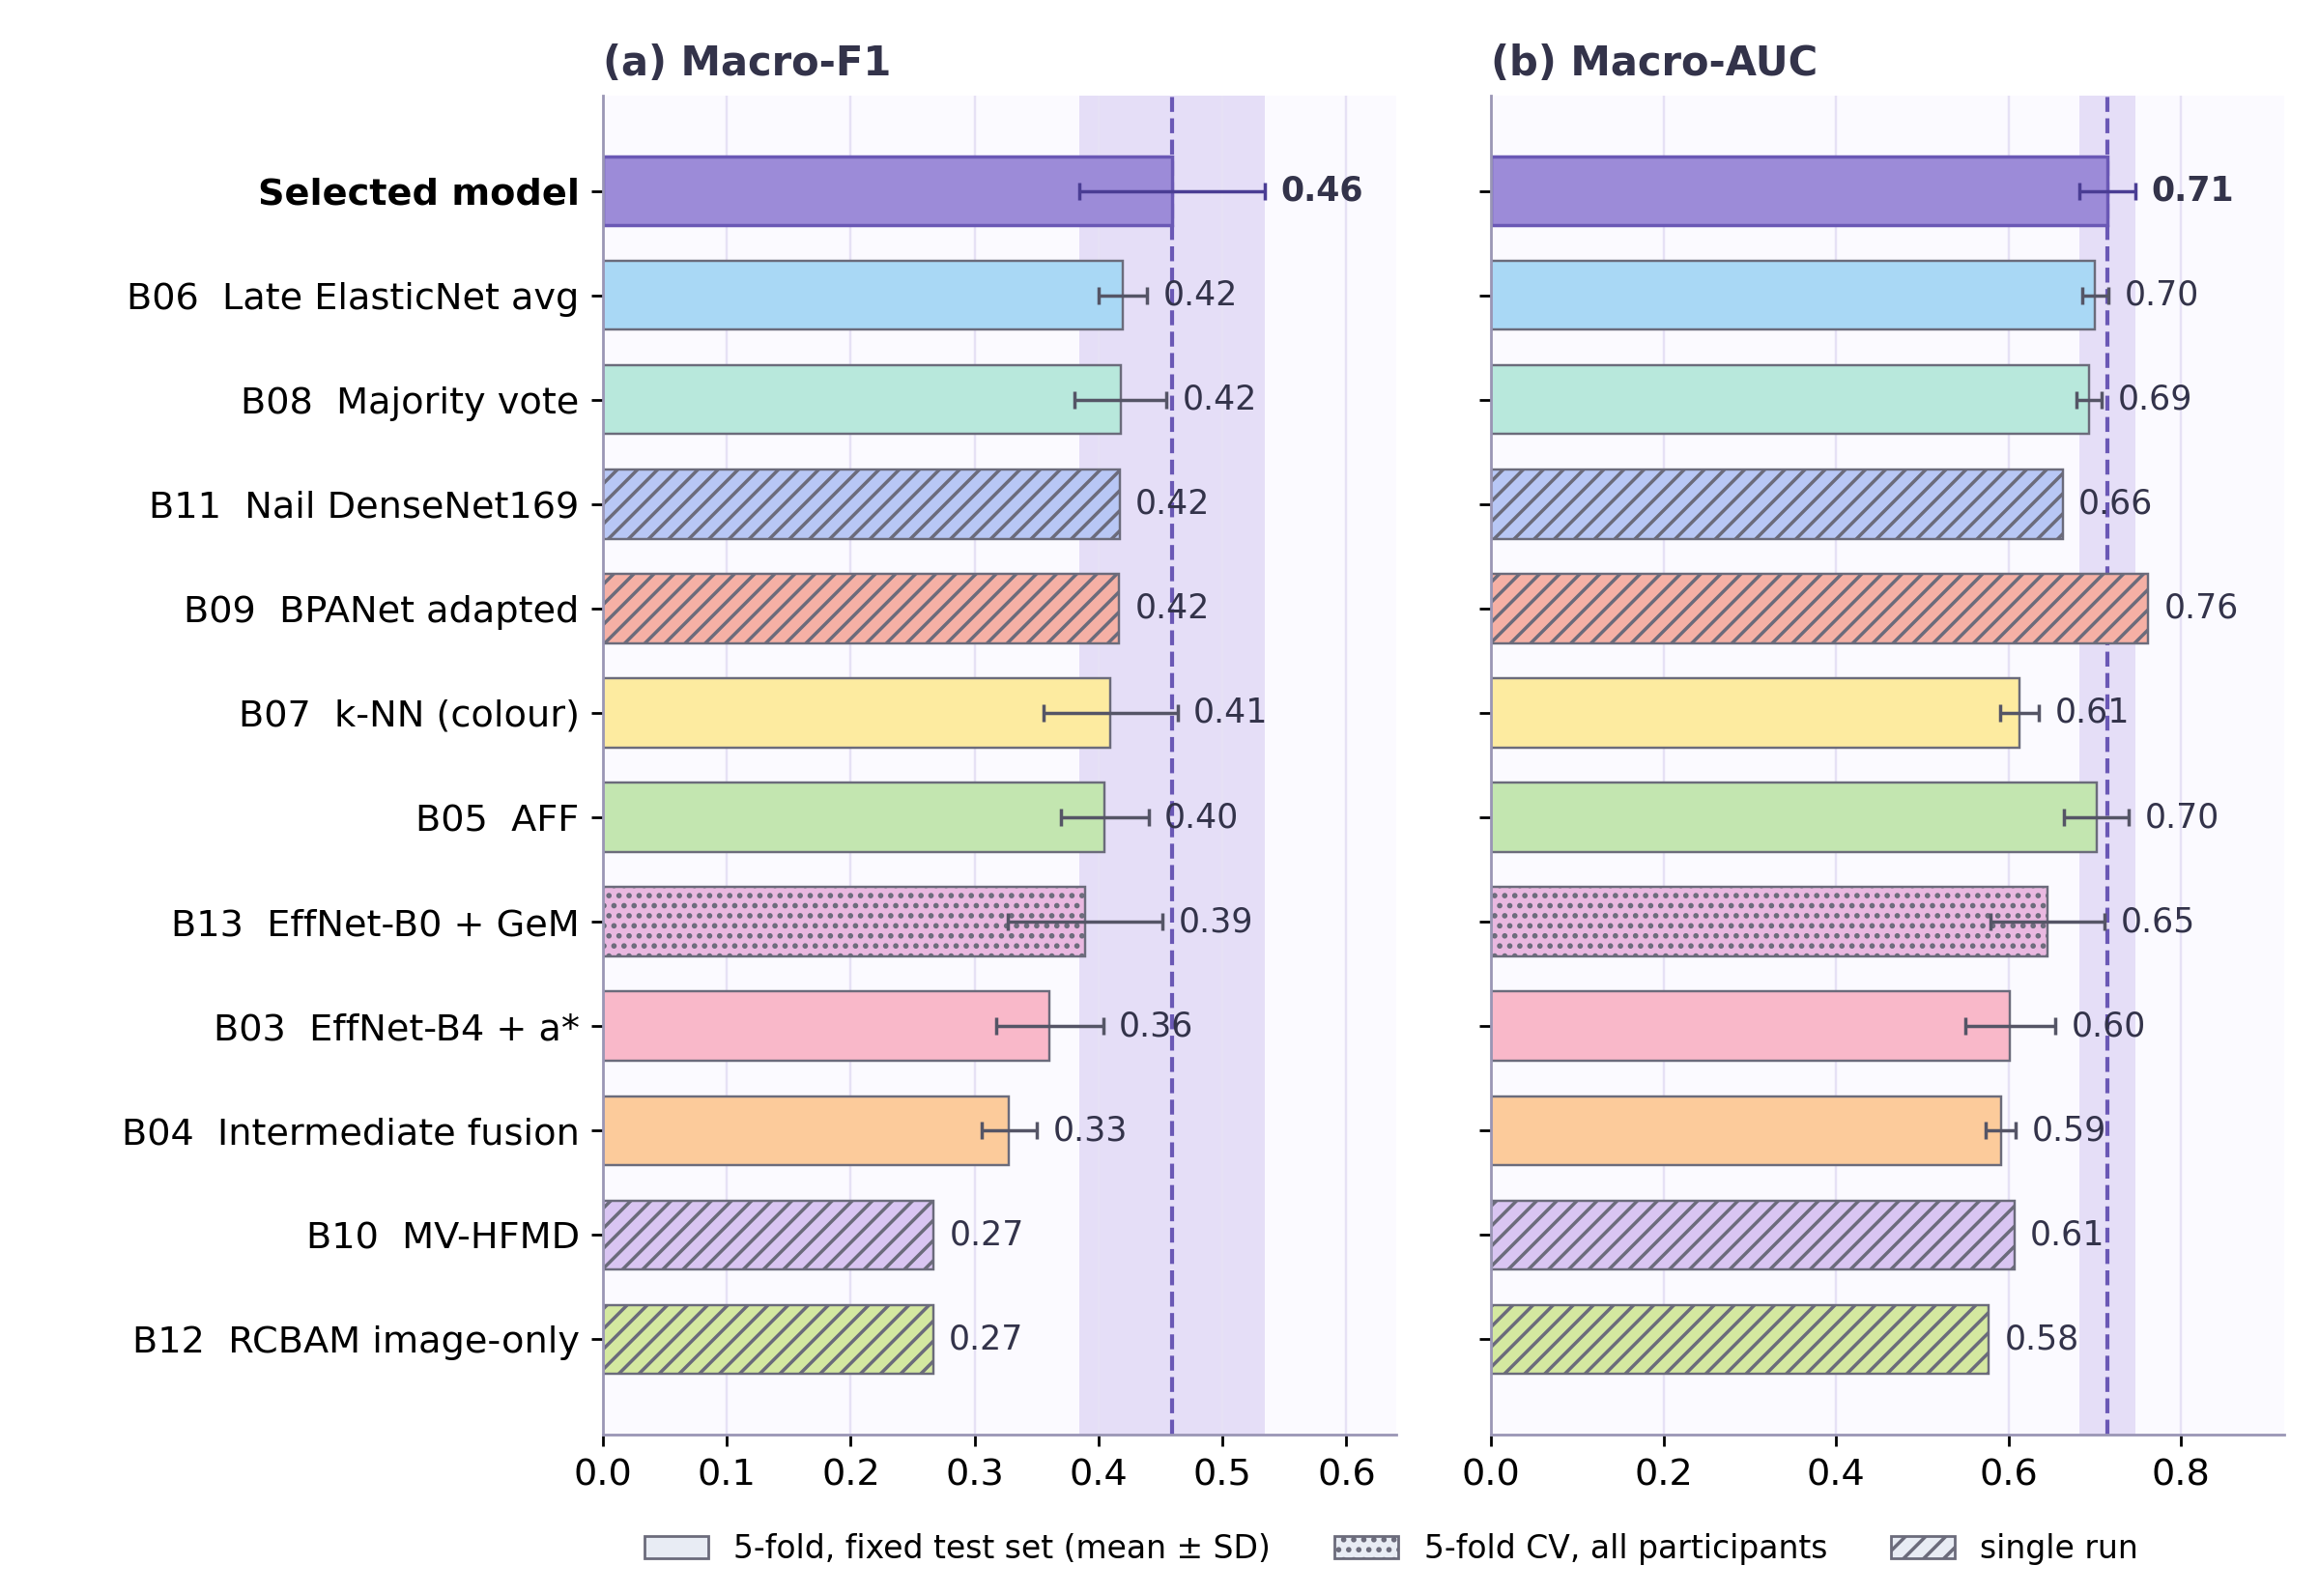
Figure 1. Macro-F1 (a) and macro-AUC (b), one run per paper. Solid bars: five-fold mean ± SD on the fixed test set. Dotted bar: five-fold CV over all participants. Hatched bars: single runs. The dashed line and band show the reference mean ± SD.
Macro-F1 and AUC. The reference model has a higher macro-F1 than the run reported for every paper. The differences fall into two groups. Seven methods lie within one reference standard deviation (0.075): AFF, late ElasticNet average, k-NN, majority vote, BPANet-adapted, the nail-only DenseNet and the nail EfficientNet-B0 (macro-F1 0.389–0.419). With the available evidence they cannot be separated from the reference. Four are clearly lower: B03 (0.361), B04 (0.328) and, by the widest margin, MV-HFMD and the RCBAM image branch (both 0.267, about 2.6 standard deviations below). The last two predict Normal for every test subject. On AUC, the only run above the reference is the single-run BPANet-adapted model (0.762); one run cannot show that it ranks subjects better. Among the five-fold benchmarks on the fixed test set, no paired permutation test reached p < 0.0625, the smallest value attainable with five folds, so no difference is statistically established.
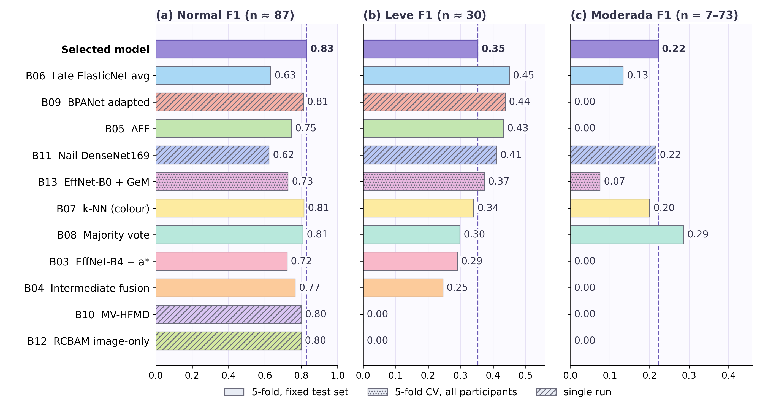
Figure 2. Per-class F1 for (a) Normal (n ≈ 87), (b) Leve (n ≈ 30) and (c) Moderada (n = 7–73, depending on the test set). Hatched and dotted bars as in Figure 1. The dashed line marks the reference.
Normal class. Figure 2a shows that the reference has the highest Normal F1 of all runs (0.83), but the margin is small: k-NN (0.81), BPANet-adapted (0.81) and majority vote (0.81) are close, and the two runs that predict Normal for every subject (MV-HFMD and the RCBAM image branch) still reach 0.80. Normal F1 therefore says little about whether anaemia is detected, because Normal is the majority class.
Minority classes. The methods differ on the two small classes (Figures 2b and 2c). Five methods have a higher Leve F1 than the reference (0.353): late ElasticNet average (0.450), BPANet-adapted (0.438), AFF (0.432), the nail-only DenseNet (0.411) and the nail EfficientNet-B0 (0.373). On Moderada, six methods score 0.000. Only majority voting (0.286) exceeds the reference (0.222), and the nail-only DenseNet is level with it (0.216). With seven to eleven Moderada subjects in most test sets, a single correct prediction moves recall by 9–14 percentage points, so no ranking on this class is reliable.

2.4 Class-wise Errors and Screening View of All Runs
Macro-F1 does not show where a model’s errors fall. Table 5 therefore gives, for the reference and for all eleven runs, the recall of each class and a Normal-versus-anaemic screening view, and Figures 3 and 4 show the confusion matrices behind it. The six runs B03–B08 and the reference are scored on the same 123 subjects, using the averaged predictions of the five fold models, so their rows can be compared with one another. B09–B13 are scored on their own splits, so their rows describe each run and do not rank it. Because an averaged-prediction matrix differs a little from the mean over fold models, the F1 implied by Table 5 differs slightly from Table 4. Collapsing Leve and Moderada into one anaemic class gives the screening view; the models were not trained for this binary task.
Table 5. Class-wise recall and Normal-versus-anaemic screening, with 95 % Wilson intervals. B03–B08 and the reference: averaged predictions of the five fold models on the same 123 test subjects. † Single run on its own test split. ‡ Predictions pooled over the five folds.
Run | Normal recall | Leve recall | Moderada recall | Sensitivity (95 % CI) | Specificity (95 % CI)
Reference | 0.885 (77/87) | 0.310 (9/29) | 0.143 (1/7) | 0.39 (14/36) [0.25, 0.55] | 0.89 (77/87) [0.80, 0.94]
B03 EffNet-B4 + a* | 0.701 (61/87) | 0.310 (9/29) | 0.000 (0/7) | 0.42 (15/36) [0.27, 0.58] | 0.70 (61/87) [0.60, 0.79]
B04 Intermediate fusion | 0.793 (69/87) | 0.241 (7/29) | 0.000 (0/7) | 0.33 (12/36) [0.20, 0.50] | 0.79 (69/87) [0.70, 0.86]
B05 AFF | 0.690 (60/87) | 0.552 (16/29) | 0.000 (0/7) | 0.61 (22/36) [0.45, 0.75] | 0.69 (60/87) [0.59, 0.78]
B06 Late ElasticNet avg | 0.494 (43/87) | 0.621 (18/29) | 0.286 (2/7) | 0.83 (30/36) [0.68, 0.92] | 0.49 (43/87) [0.39, 0.60]
B07 k-NN (colour) | 0.885 (77/87) | 0.276 (8/29) | 0.143 (1/7) | 0.31 (11/36) [0.18, 0.47] | 0.89 (77/87) [0.80, 0.94]
B08 Majority vote | 0.828 (72/87) | 0.241 (7/29) | 0.429 (3/7) | 0.47 (17/36) [0.32, 0.63] | 0.83 (72/87) [0.73, 0.89]
B09 BPANet adapted† | 0.816 (71/87) | 0.483 (14/29) | 0.000 (0/7) | 0.53 (19/36) [0.37, 0.68] | 0.82 (71/87) [0.72, 0.88]
B10 MV-HFMD† | 1.000 (82/82) | 0.000 (0/30) | 0.000 (0/11) | 0.00 (0/41) [0.00, 0.09] | 1.00 (82/82) [0.96, 1.00]
B11 Nail DenseNet169† | 0.518 (43/83) | 0.500 (15/30) | 0.364 (4/11) | 0.71 (29/41) [0.56, 0.82] | 0.52 (43/83) [0.41, 0.62]
B12 RCBAM image-only† | 1.000 (165/165) | 0.000 (0/61) | 0.000 (0/22) | 0.00 (0/83) [0.00, 0.04] | 1.00 (165/165) [0.98, 1.00]
B13 EffNet-B0 + GeM‡ | 0.702 (386/550) | 0.420 (84/200) | 0.068 (5/73) | 0.54 (147/273) [0.48, 0.60] | 0.70 (386/550) [0.66, 0.74]
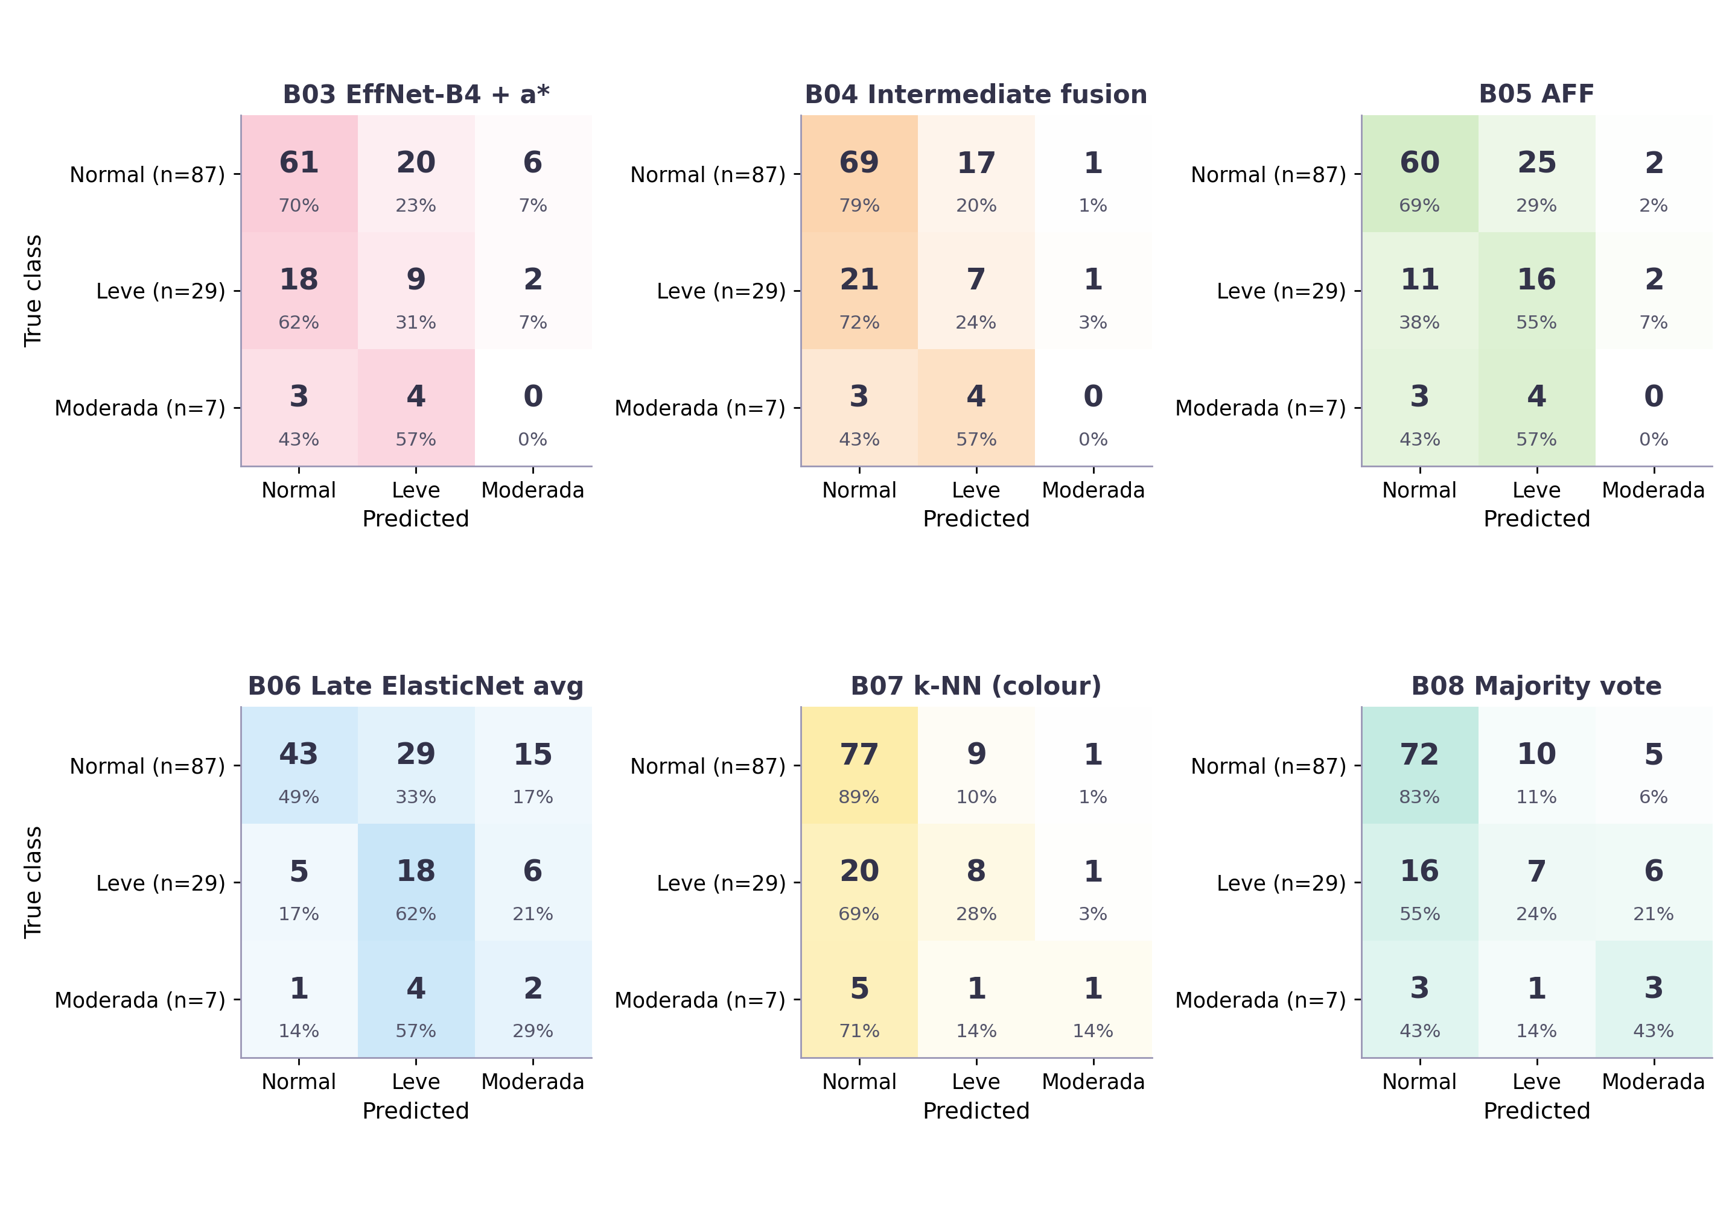
Figure 3. Confusion matrices of B03–B08 on the common test set of 123 subjects (averaged predictions of the five fold models). Large numbers are counts; the percentage is the share of each true class.
Runs on the common test set. The reference misses 22 of 36 anaemic subjects (sensitivity 0.39) but wrongly flags only 10 of 87 Normal subjects (specificity 0.89). B07 (k-NN) has almost the same profile (0.31 and 0.89). B04 (0.33 and 0.79) and B08 (0.47 and 0.83) lie between the two. B03 and B05 flag more anaemic subjects (0.42 and 0.61) at the cost of specificity (0.70 and 0.69), and their specificity intervals lie just below the reference interval. B06 is the extreme case: it finds 30 of 36 anaemic subjects (0.83) but only 43 of 87 Normal subjects are correct (0.49), and 15 Normal subjects are called Moderada; both of its intervals are clearly separated from the reference. On Moderada, B03, B04 and B05 find none of the seven subjects, the reference and B07 find one, B06 two and B08 three. The macro-F1 values in Table 4 are close because these methods trade sensitivity against specificity at different points and not because they make the same errors.
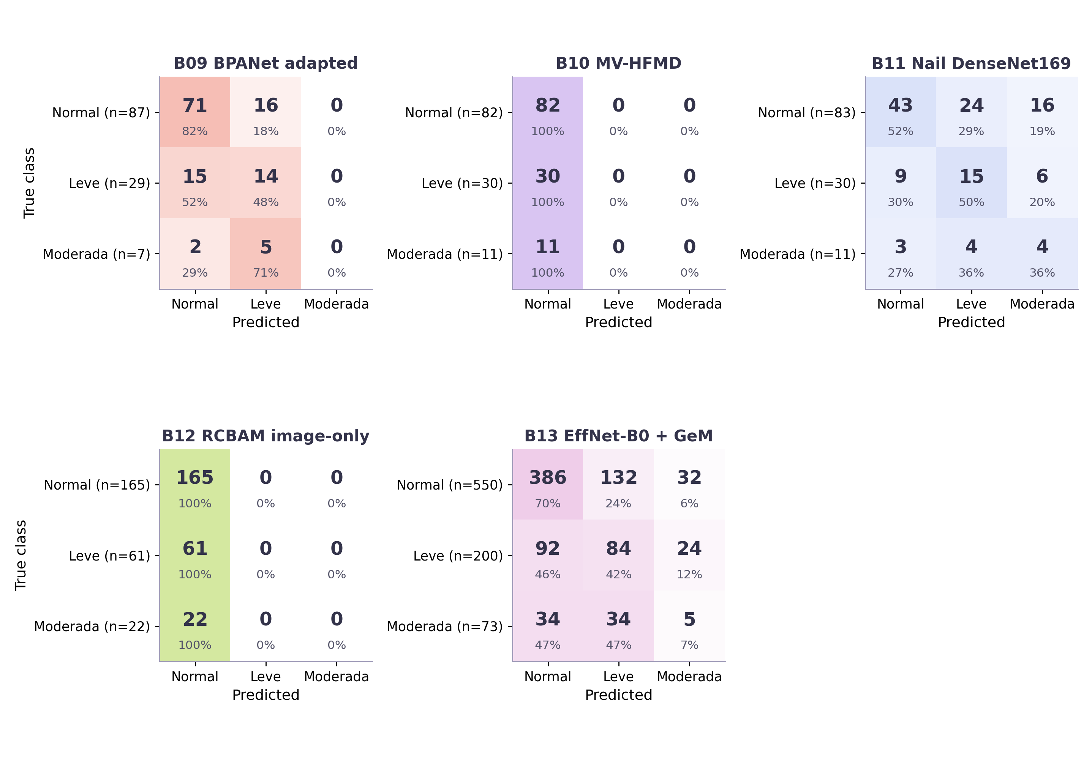
Figure 4. Confusion matrices of the single runs B09–B12 and of the cross-validated B13, each on its own test set. Large numbers are counts; the percentage is the share of each true class.
Runs on their own splits. The BPANet-adapted model finds 14 of 29 Leve subjects but none of the seven Moderada subjects. The nail-only DenseNet is the only single run that finds Moderada subjects at a useful rate (4 of 11), but only 43 of 83 Normal subjects are correct and 16 are called Moderada. B13 (pooled over its five folds) is more moderate: 70 % of Normal and 42 % of Leve subjects are correct, but only 5 of 73 Moderada. MV-HFMD and the RCBAM image branch predict Normal for every subject. Across all runs the reference is conservative, whereas the nail-only DenseNet (sensitivity 0.71, specificity 0.52) and B06 are far more aggressive. The intervals overlap for most pairs, so no operating point is confirmed as better.
The training logs explain several of these results. The MV-HFMD checkpoint was chosen by validation accuracy and falls on epoch 2, where its validation macro-F1 (0.267) equals that of an all-Normal predictor; its validation loss later rose from 1.50 to 4.55 while the training loss fell to 0.26. The BPANet-adapted run stayed at the all-Normal level for five of its first six epochs and peaked at a validation macro-F1 of only 0.328, yet scored 0.416 on the test set, which illustrates how noisy single runs are on this dataset. The reference model also overfits early, with its mean validation macro-F1 highest at epoch 2.

2.5 Interpretation
The reference model keeps its place, but its lead is small. It scores highest on macro-F1 against the method of every paper, but seven of the eleven methods are within one standard deviation of it. The ordering of the reference and BPANet-adapted flips if the reference misses its single correct Moderada subject, so the evidence is best read as a tie between them.
The methods differ mainly in their operating point. The reference has the highest macro-precision (0.500) and the highest Normal F1 (0.83), and is conservative. The late ElasticNet average has a higher macro-recall (0.484 against 0.460), the nail-only DenseNet equals it, and five methods have a higher Leve F1. Macro-F1 therefore ranks the methods closely while the trade-off between missed cases and false alarms differs widely (Table 5): on the common test set the sensitivity ranges from 0.31 (B07) to 0.83 (B06) and the specificity from 0.49 to 0.89.
Nail-only models work only when the training is sound. Three runs use the nail photograph alone. The pretrained, augmented, class-weighted models reach 0.417 (DenseNet169, B11) and 0.389 (EfficientNet-B0, B13) macro-F1, which is 91 % and 85 % of the reference. The pretrained MobileNetV2 branch trained without class weights or augmentation (B12, 0.266) predicts Normal for every subject. This suggests that the nail photograph carries a usable part of the signal, and that the training recipe matters more than the architecture; but the splits and budgets differ between these runs, and no nail-only baseline was run under the common protocol, so the claim is weak.
Poor results reflect the adaptation, not necessarily the method. MV-HFMD fails because of its checkpoint rule on an imbalanced validation set, B12 because its image branch collapses to the majority class without class weighting, and the weak B03 and B04 results come from three-class re-implementations that depart from the original binary papers. Published accuracies (0.65–0.99, mostly on binary tasks with different data and, for some papers, augmentation before splitting) cannot be ranked against the reproduced values and give no support for placing any paper above or below the reference.

2.6 Limitations and Summary
The benchmarks are not a perfectly fair contest. They use three different protocols, the single runs have no measured run-to-run variation, and B13 is not scored on the reference’s test subjects. The reference was selected among several configurations on the same test set, which may favour it. Other runs exist that are not reported here, including the independent reproduction of the Asare et al. paper noted in Table 3. For B07, naive Bayes on colour features (0.480 ± 0.017; p = 0.6875, higher in three of five folds) scored above the reference mean; it is not the paper’s headline method, and the difference is not significant, but the reference is therefore not the highest score among all 17 variants the first team member evaluated. For B13, the fingertip EfficientNet-B0 of the third team member reached 0.447 under five-fold cross-validation, below the reference. Moderada has only 7–73 test subjects. Clinical suitability and computational cost were not measured.
In summary, under a common three-class task none of the eleven reported runs exceeded the reference model on macro-F1. Seven lie within one standard deviation of it, four are clearly lower, and the BPANet-adapted run exceeds it only on AUC and Leve F1. Establishing a ranking would need the same split for every method, several seeds or repeated cross-validation, and more Moderada subjects.

